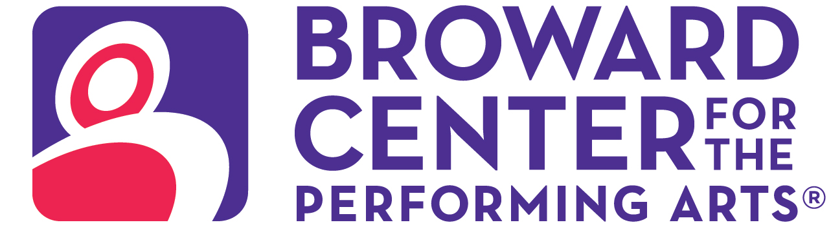

September 23, 2024
Media Contact:
Amy Hoffman, 954-303-4621
ahoffman@piersongrant.com
Jan Goodheart, Broward Center
jgoodheart@browardcenter.org

Link to art: https://www.dropbox.com/scl/fo/g1y4xo1gtu2djwkhup81a/ALOpGpv51aUkIXaLfRyYEMU?rlkey=jp78pk4new5y97dytseu3wt1j&st=b3ttbhf4&dl=0

SLOW BURN THEATRE COMPANY CASTS ITS CHARMS ON AUDIENCES WHEN “THE WITCHES OF EASTWICK” COMES TO BROWARD CENTER FOR THE PERFORMING ARTS

FORT LAUDERDALE – Just in time for Halloween, Slow Burn Theatre Company’s 2024/2025 season, presented by American National Bank and Visit Lauderdale, opens with the South Florida premiere of The Witches of Eastwick on Saturday, October 19 – Sunday November 3 in the Amaturo Theater at the Broward Center for the Performing Arts.

When three desperate housewives in small town America wish for the man of their dreams, they get more than they bargain for in this sexy and bewitching musical comedy filled with adult humor.
Based on the John Updike novel and the 1987 Hollywood film about three bored New England witches who conjure up a wicked lover, the original West End production was nominated for an Olivier Award for Best New Musical. The New York Times called it “a truly magical show,” with a score that Variety hailed as “eclectic and…immensely likable.”

The musical has book and lyrics by John Dempsey and music by Dana P. Rowe, the creative team behind Zombie Prom and The Fix, and features a showstopping score including “Make Him Mine,” “Dirty Laundry,” “Dance With the Devil” and “I Wish I May.”

The wickedly talented ensemble cast includes Philip Bryan as the devilish Darryl van Horne, alongside Gail Bennett as Alexandra Spofford, Lindsey Corey as Sukie Rougemont and Leah Sessa as Jane Smart, the titular witches. Rounding out the spellbinding cast are Britte Steele as Felicia Gabriel, Christopher Dreeson as Clyde Gabriel, and Tony Carrubba as Michael Spofford.

Slow Burn Theatre Artistic Director Patrick Fitzwater directs and is joined by a creative team of musical director Travis Smith, associate director and choreographer Trent Soyster, scenic designer Kelly James Tighe, lighting designer Clifford Spulock Lighting, costume designer Rick Peña, production stage manager Jeffry George, assistant stage manager Jolie Rubinchik, technical director Timothy Shaun Dickey.

Performance times vary with an open captioned performance on Sunday, October 27 at 2 p.m.

The production is licensed by Music Theatre International and presented through special arrangement with Cameron Mackintosh Ltd.

Single tickets to Slow Burn Theatre’s 2024/2025 season are on sale now. Supported by American National Bank and Visit Lauderdale, the season in the Amaturo Theater features five musicals with enduring stories that have captivated audiences in movie theaters and on stage: The Witches of Eastwick (October 19 – Nov. 3); Anastasia The Musical (Dec. 21 – Jan. 5); Parade (Feb. 8 – 23); Something Rotten! (March 29 – April 13); and The Bodyguard The Musical (June 7 – 22).

Ticketmaster is the only official ticketing service of the Broward Center and The Parker. Buy tickets online at BrowardCenter.org, or Ticketmaster.com; by phone at 954.462.0222; in person at the Broward Center’s AutoNation Box Office.

The Broward Center for the Performing Arts is located at 201 SW Fifth Ave. in Fort Lauderdale. For more information visit BrowardCenter.org, like us on Facebook at Facebook.com/BrowardCenter and Facebook.com/BrowardCenterEducation, follow us on Twitter and Instagram @BrowardCenter, subscribe to our channel at YouTube.com/user/BrowardCenter and join the conversation with #BrowardCenter.
Major support for the Slow Burn Theatre Company season is provided by the Broward County Cultural Division, the Cultural Council, and the Broward County Board of County Commissioners. Sponsored in part by American National Bank and Visit Lauderdale.
The Broward Center 2024/2025 season is supported by the Broward Performing Arts Foundation. AutoNation, Greater Fort Lauderdale Convention & Visitors Bureau and Spirit.

About The Broward Center for the Performing Arts
One of America’s premier performing arts venues, the Broward Center for the Performing Arts presents more than 700 performances each year to more than 700,000 patrons, showcasing a wide range of exciting cultural programming and events. Guest experiences at the Broward Center include the all-inclusive Spirit Club Level and Nicklaus Children’s Hospital Intermezzo Lounge, special events in the Huizenga Pavilion, waterfront dining at Marti’s New River Bistro and innovative classes and workshops for all ages at the Rose Miniaci Arts Education Center. With one of the largest arts-in-education programs in the United States, the Broward Center serves more than 100,000 students annually. The Broward Center for the Performing Arts is located at 201 SW Fifth Ave. in Fort Lauderdale. For more information, visit BrowardCenter.org.

###

