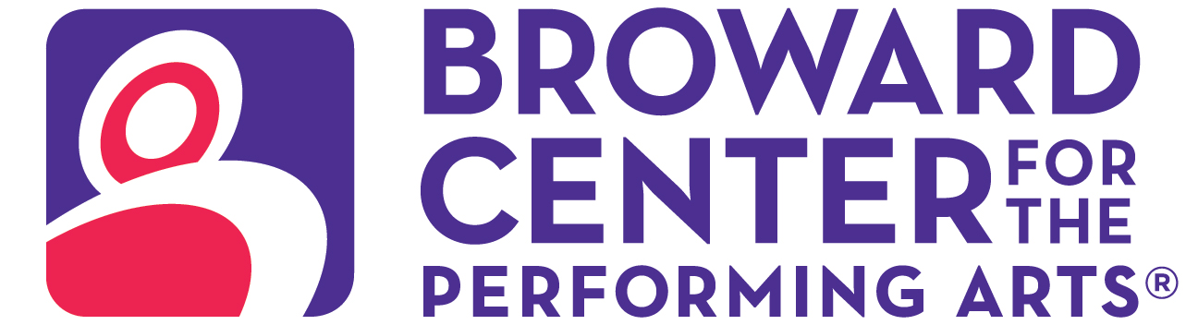

March 11, 2025
Media Contact:
Amy Hoffman, 954-303-4621
ahoffman@piersongrant.com
Jan Goodheart, Broward Center
jgoodheart@browardcenter.org

Link to art: https://www.dropbox.com/scl/fo/g1y4xo1gtu2djwkhup81a/ALOpGpv51aUkIXaLfRyYEMU?rlkey=jp78pk4new5y97dytseu3wt1j&st=b3ttbhf4&dl=0

SLOW BURN THEATRE COMPANY PRESENTS “SOMETHING ROTTEN!”
AT THE BROWARD CENTER FOR THE PERFORMING ARTS

FORT LAUDERDALE – Not content with just one day, Slow Burn Theatre Company delivers weeks of April foolishness with “Something Rotten!” as part of its 2024/2025 Season supported by American National Bank and Visit Lauderdale Saturday, March 29 – Sunday, April 13 in the Amaturo Theater at the Broward Center for the Performing Arts, including an open captioned performance on Sunday, April 6 at 2 p.m.

Proclaimed “Broadway’s big, fat hit!” by the New York Post and nominated for 10 Tony Awards, this hilarious smash journeys back to 1595 as brothers Nick and Nigel Bottom compete to write a hit play against the popularity of the insufferable superstar Shakespeare. When a local soothsayer foretells that the future of theater involves singing, dancing and acting at the same time, they set out to write the world’s first musical.
With a book by Karey Kirkpatrick and John O'Farrell and music and lyrics by Karey Kirkpatrick and Wayne Kirkpatrick, “Something Rotten” wears its heart on its ruffled sleeve and sequins in its soul. New York Magazine proclaims this laugh out loud, show-stopping musical comedy “‘The Producers’ + ‘The Book of Mormon’ x ‘The Drowsy Chaperone.’ Squared!”
The cast features Jerel T. Brown, Ryan Crout, Woodrow Jackson Helms, Matthew W. Korinko*, Tyler Manemeit, Ralph Meitzler*, Kristi Rose Mills, Michael Dean Morgan* and Leah Sessa*.

They are joined by a talented ensemble comprised of Abbey Alder, Aaron Atkinson, Alexander Blanco, Jamal Campbell*, Madeline Dunn, Deborah Katz, Anthony Lobo, Caiti Marlowe, Michael Materdomini, Taylor Hilt Mitchell*, Charles Page, Steven Ross-Dybash, Ashley Valent and Madison Wilcox.

Director Patrick Fitzwater leads a creative team with Choreographer Nicolette Quintero, Music Director Ryan Crout, Scenic Design S. Benjamin Farrar, Costume Design Gregg Barnes, Lighting Design Eric Norbury, Costume Coordinator Rick Peña, Sound Design Dan Donato, Wig & Prop Design Patrick Fitzwater, Technical Director Timothy S. Dickey, Assistant Stage Manager Jolie Rubinchik* and Production Stage Manager Jeffry George*.

Major support of Slow Burn Theatre Company is provided by the Broward County Cultural Division, the Cultural Council, the Broward County Board of County Commissioners and Funding Arts Broward (FAB). Sponsored in part by American National Bank and Visit Lauderdale. Student and community complimentary tickets are subsidized and underwritten by the Salah Foundation and the Cornelia T. Bailey Foundation.

Performance times vary with an open captioned performance on Sunday, April 6 at 2 p.m., in which spoken dialogue scrolls across a digital screen as the action takes place on stage. “Something Rotten” is presented through special arrangement with Music Theatre International (MTI).

Ticketmaster is the only official ticketing service of the Broward Center and The Parker. Buy tickets online at BrowardCenter.org, or Ticketmaster.com; by phone at 954.462.0222; in person at the Broward Center’s AutoNation Box Office.

The Broward Center for the Performing Arts is located at 201 SW Fifth Ave. in Fort Lauderdale. For more information visit BrowardCenter.org, like us on Facebook at Facebook.com/BrowardCenter and Facebook.com/BrowardCenterEducation, follow us on Twitter and Instagram @BrowardCenter, subscribe to our channel at YouTube.com/user/BrowardCenter and join the conversation with #BrowardCenter.
The Broward Center 2024/2025 season is supported by the Broward Performing Arts Foundation, AutoNation, Greater Fort Lauderdale Convention & Visitors Bureau, Spirit and Nicklaus Children’s Health System.

* Member of the Actors' Equity Association (AEA).

About The Broward Center for the Performing Arts
One of America’s premier performing arts venues, the Broward Center for the Performing Arts presents more than 850 performances each year to more than 600,000 patrons, displaying a wide range of exciting cultural programming and events. Guest experiences at the Broward Center include the all-inclusive Spirit Club Level, the Nicklaus Children’s Health System Intermezzo Lounge, special events in the Huizenga Pavilion, waterfront dining at Marti’s New River Bistro and innovative classes and workshops for all ages at the Rose Miniaci Arts Education Center. With one of the largest arts-in-education programs in the United States, the Broward Center serves more than 100,000 students annually. The Broward Center also manages The Parker, an iconic Fort Lauderdale venue, the Rose & Alfred Miniaci Performing Arts Center on the campus of Nova Southeastern University, and the Aventura Arts & Cultural Center in Miami-Dade County. The Broward Performing Arts Foundation, Inc. receives and maintains funds to sustain, develop and secure the future of the Broward Center. For more information, visit BrowardCenter.org.

About Slow Burn Theatre Company
Founded in 2009 by Patrick Fitzwater and Matthew Korinko, Slow Burn Theatre Company is one of South Florida’s leading professional musical theater organizations, celebrated for its bold productions and fearless creativity. With a mission to bring high-quality, thought-provoking, and entertaining performances to life, Slow Burn has earned a reputation for pushing boundaries and delivering dynamic interpretations of beloved musicals alongside lesser-known gems. Based at the Broward Center for the Performing Arts, Slow Burn Theatre Company offers an extraordinary theatrical experience that combines impeccable artistry, live music, and an unparalleled commitment to storytelling. The company has grown exponentially over its history, evolving from an ambitious grassroots effort to a cornerstone of South Florida’s cultural scene, thanks to the dedication of its founders, talented artists, and loyal supporters. Now in its 15th anniversary season, Slow Burn Theatre Company celebrates a legacy of innovation, resilience, and community connection. From intimate stages to grand productions, Slow Burn continues to inspire audiences with its passion for the arts and commitment to making theater accessible to all.For more information, visit Slow Burn Theatre Company’s website at http://slowburntheatre.org/.

###

