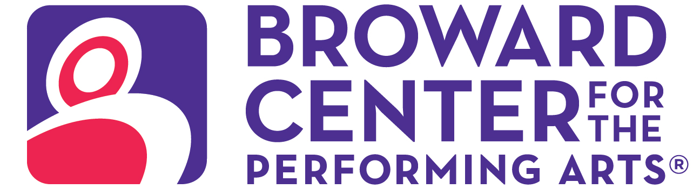

January 15, 2025
Media Contact:
Amy Hoffman, 954-303-4621
ahoffman@piersongrant.com
Jan Goodheart, Broward Center
jgoodheart@browardcenter.org

Link to art: https://www.dropbox.com/scl/fo/g1y4xo1gtu2djwkhup81a/ALOpGpv51aUkIXaLfRyYEMU?rlkey=jp78pk4new5y97dytseu3wt1j&st=b3ttbhf4&dl=0

SLOW BURN THEATRE COMPANY PRESENTS “PARADE”
AT THE BROWARD CENTER FOR THE PERFORMING ARTS

FORT LAUDERDALE – Slow Burn Theatre Company presents “Parade,” a powerful and poignant musical revival based on the true story of the trial and lynching of Leo Frank, as part of its 2024/2025 Season supported by American National Bank and Visit Lauderdale Saturday, February 8 – Sunday, February 23 in the Amaturo Theater at the Broward Center for the Performing Arts, including an open captioned performance on Sunday, February 16 at 2 p.m. and a series of post-performance chats with an ADL representative on Saturday, February 15, at 1 p.m. and 7:30 p.m. and Sunday, February 16, at 2 p.m.

Winner of the 1999 Tony awards for Best Score (Jason Robert Brown, who also wrote the lyrics) and Best Book of a Musical (Alfred Uhry) as well as the 2023 Tony for Best Revival of a Musical, “Parade,” co-conceived and directed on Broadway by Harold Prince, follows a newlywed Jewish couple, Leo and Lucille Frank, who are struggling to make a life in the old red hills of Georgia. When Leo is accused of an unspeakable crime, it propels them into an unimaginable test of faith, humanity, justice and devotion.

Hailed as an “an essential American musical” by Variety, “Parade” is a “phenomenal production that feels more poignant and powerful than ever,” according to Entertainment Weekly. Time Out New York writes, “What you hear at this Parade…will echo for a long time to come.”

Directed by Slow Burn Theatre Artistic Director and Carbonell Award winner Patrick Fitzwater and presented through special arrangement with Music Theatre International (MTI), Slow Burn’s riveting and gloriously hopeful production features lead actors Justin Albinder* (Leo Frank) and Mikayla Cohen (Lucille Frank) joined by Kevin Patrick Martin* (Hugh Dorsey), Michael Hunsaker* (Britt Craig), Erik Schark* (Judge Roan/Old Soldier), Jessica Balton (Mary Phagan), Joel Hunt (Frankie Epps), Kareema Khouri* (Minola “Minnie” McKnight/Angela), Chaz Rose* (Newt Lee/Jim Conley/Riley), Michael Materdomini (Governor John Slanton), Landon Summers (Tom Watson/Detective Starnes), Ana Marie Calise (Mrs. Phagan), Nolan Montgomery (Young Soldier/Fiddlin John/others), Bridget Rose Pirrota (Iola Stover), Erica Gouldthorpe (Monteen/others), Sofie Poliakoff (Essie/others), Allyson Rosenblum (Sally Slanton), Steven Ross-Dybash (Mr. Peavy), Eli Jacobson (Officer Ivey/others), Austin Gladstone (Luther Rosser/others), Elizabeth Sackett (Nurse/others), Sam Hoffman (Mr. Turner/others) and Sara Sun Park (Nina Formby/others).

The creative team features direction and musical staging by Fitzwater joined by Music Director Travis Smith, Lighting Designer Eric Norbury, Scenic Designer Nikolas Serrano, Costume Designer Rick Peña, Technical Director Timothy Dickey, Production Stage Manager Jeffry George* and Assistant Stage Manager Jolie Rubinchik*.

Performance times vary with an open captioned performance on Sunday, February 16 at 2 p.m. Following the performances on Saturday, February 15, at 1 p.m. and 7:30 p.m. and Sunday, February 16, at 2 p.m., an ADL representative will present a 15-minute talk with a Q&A.

Single tickets to Slow Burn Theatre’s 2024/2025 season are on sale now. Supported by American National Bank and Visit Lauderdale, the season continues in the new year with “Something Rotten!” (March 29 – April 13) and “The Bodyguard The Musical” (June 7 – 22).

Ticketmaster is the only official ticketing service of the Broward Center and The Parker. Buy tickets online at BrowardCenter.org, or Ticketmaster.com; by phone at 954.462.0222; in person at the Broward Center’s AutoNation Box Office.

The Broward Center for the Performing Arts is located at 201 SW Fifth Ave. in Fort Lauderdale. For more information visit BrowardCenter.org, like us on Facebook at Facebook.com/BrowardCenter and Facebook.com/BrowardCenterEducation, follow us on Twitter and Instagram @BrowardCenter, subscribe to our channel at YouTube.com/user/BrowardCenter and join the conversation with #BrowardCenter.
Major support of Slow Burn Theatre Company is provided by the Broward County Cultural Division, the Cultural Council and the Broward County Board of County Commissioners. Sponsored in part by American National Bank and Visit Lauderdale. Student and community complimentary tickets are subsidized and underwritten by the Salah Foundation and the Cornelia T. Bailey Foundation.

The Broward Center 2024/2025 season is supported by the Broward Performing Arts Foundation, AutoNation, Greater Fort Lauderdale Convention & Visitors Bureau, Spirit and Nicklaus Children’s Health System.

* Member of the Actors' Equity Association (AEA).

About The Broward Center for the Performing Arts
One of America’s premier performing arts venues, the Broward Center for the Performing Arts presents more than 850 performances each year to more than 600,000 patrons, displaying a wide range of exciting cultural programming and events. Guest experiences at the Broward Center include the all-inclusive Spirit Club Level, the Nicklaus Children’s Health System Intermezzo Lounge, special events in the Huizenga Pavilion, waterfront dining at Marti’s New River Bistro and innovative classes and workshops for all ages at the Rose Miniaci Arts Education Center. With one of the largest arts-in-education programs in the United States, the Broward Center serves more than 100,000 students annually. The Broward Center also manages The Parker, an iconic Fort Lauderdale venue, the Rose & Alfred Miniaci Performing Arts Center on the campus of Nova Southeastern University, and the Aventura Arts & Cultural Center in Miami-Dade County. The Broward Performing Arts Foundation, Inc. receives and maintains funds to sustain, develop and secure the future of the Broward Center. For more information, visit BrowardCenter.org.

About Slow Burn Theatre Company
Founded in 2009 by Patrick Fitzwater and Matthew Korinko, Slow Burn Theatre Company is one of South Florida’s leading professional musical theater organizations, celebrated for its bold productions and fearless creativity. With a mission to bring high-quality, thought-provoking, and entertaining performances to life, Slow Burn has earned a reputation for pushing boundaries and delivering dynamic interpretations of beloved musicals alongside lesser-known gems. Based at the Broward Center for the Performing Arts, Slow Burn Theatre Company offers an extraordinary theatrical experience that combines impeccable artistry, live music, and an unparalleled commitment to storytelling. The company has grown exponentially over its history, evolving from an ambitious grassroots effort to a cornerstone of South Florida’s cultural scene, thanks to the dedication of its founders, talented artists, and loyal supporters. Now in its 15th anniversary season, Slow Burn Theatre Company celebrates a legacy of innovation, resilience, and community connection. From intimate stages to grand productions, Slow Burn continues to inspire audiences with its passion for the arts and commitment to making theater accessible to all.For more information, visit Slow Burn Theatre Company’s website at http://slowburntheatre.org/.

###

