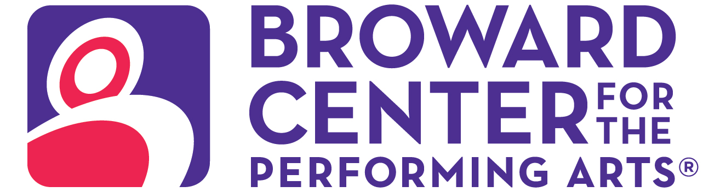

May 9, 2025
Media Contact:
Amy Hoffman, 954-303-4621
ahoffman@piersongrant.com
Jan Goodheart, Broward Center
jgoodheart@browardcenter.org

Link to art: https://www.dropbox.com/scl/fo/g1y4xo1gtu2djwkhup81a/ALOpGpv51aUkIXaLfRyYEMU?rlkey=jp78pk4new5y97dytseu3wt1j&st=b3ttbhf4&dl=0

SLOW BURN THEATRE COMPANY PRESENTS
WEST END HIT “THE BODYGUARD THE MUSICAL”
AT THE BROWARD CENTER FOR THE PERFORMING ARTS
“American Idol” finalist Ta-Tynisa Wilson stars in lead role

FORT LAUDERDALE – Slow Burn Theatre Company’s 2024/2025 Season in the Amaturo Theater supported by American National Bank and Visit Lauderdale culminates with a sizzling summer production of the West End hit “The Bodyguard The Musical” Saturday June 7 – Sunday, June 22, including an open captioned performance on Sunday, June 15 at 2 p.m.

When former Secret Service agent turned bodyguard Frank Farmer is hired to protect superstar Rachel Marron from an unknown stalker, each expects to be in charge; what they don’t expect is to fall in love.

Starring “American Idol” finalist Ta-Tynisa Wilson* as Rachel Marron, this breathtakingly romantic thriller that The Guardian hailed as a “music-forward, funny, fast-paced operation” and a “joyful take on Whitney Houston's greatest hits” features “Queen of the Night,” “So Emotional,” “One Moment in Time,” “Saving All My Love,” “Run to You,” “I Have Nothing,” “I Wanna Dance with Somebody,” and one of the biggest-selling songs of all time, “I Will Always Love You.”

Originally produced in the West End by Michael Harrison and David lan, “The Bodyguard The Musical” features a book by Alexander Dinelaris and is based on a screenplay by Lawrence Kasdan for the Warner Bros. film. It is produced with permission of Warner Bros. Theatre Venture, Inc.

In addition to Wilson, the principal cast includes Gabriell Salgado* (Frank Farmer), Lillie Eliza Thomas* (Nicki Marron), Timothy Davis (The Stalker) and Jaxon Compas (Fletcher).

They are joined by a talented ensemble comprised of Matthew Korinko*, Jerel T. Brown, Michael Materdomini, Eli Flynn, Paul Tuaty, Ethan Telfort, Zach “Zoo” Finkelstein, Amanda Lopez, Cat Pagano*, Mikayla Queeley, Daniella Santos, Kaareema Khouri*, Nayomi Braaf and Steven Ross Dybash.

Director Patrick Fitzwater leads a creative team featuring Nikolas Serrano (set design), Clifford Spulock Lighting, LLC (lighting), Rick Peña (costumes), Ryan Crout (music direction), Reynel Reynaldo (choreography), Jeffry George* and Jolie Rubinchik* (stage management), and Darius J. Manuel (production assistant).

Major support of Slow Burn Theatre Company is provided by the Broward County Cultural Division, the Cultural Council, the Broward County Board of County Commissioners and sponsored in part by American National Bank and Visit Lauderdale. Student and community complimentary tickets are subsidized and underwritten by the Salah Foundation and the Cornelia T. Bailey Foundation. This production is additionally supported by Business for the Arts of Broward.

Performance times vary with an open captioned performance on Sunday, June 15 at 2 p.m., in which spoken dialogue scrolls across a digital screen as the action takes place on stage. “The Bodyguard” is presented through special arrangement with Theatrical Rights Worldwide (TRW) www.theatricalrights.com.

Ticketmaster is the only official ticketing service of the Broward Center and The Parker. Buy tickets online at BrowardCenter.org, or Ticketmaster.com; by phone at 954.462.0222; in person at the Broward Center’s AutoNation Box Office.

The Broward Center for the Performing Arts is located at 201 SW Fifth Ave. in Fort Lauderdale. For more information visit BrowardCenter.org, like us on Facebook at Facebook.com/BrowardCenter and Facebook.com/BrowardCenterEducation, follow us on Twitter and Instagram @BrowardCenter, subscribe to our channel at YouTube.com/user/BrowardCenter and join the conversation with #BrowardCenter.
The Broward Center 2024/2025 season is supported by the Broward Performing Arts Foundation, AutoNation, Greater Fort Lauderdale Convention & Visitors Bureau, Spirit and Nicklaus Children’s Health System.

* Member of the Actors' Equity Association (AEA).

About The Broward Center for the Performing Arts
One of America’s premier performing arts venues, the Broward Center for the Performing Arts presents more than 850 performances each year to more than 600,000 patrons, displaying a wide range of exciting cultural programming and events. Guest experiences at the Broward Center include the all-inclusive Spirit Club Level, the Nicklaus Children’s Health System Intermezzo Lounge, special events in the Huizenga Pavilion, waterfront dining at Marti’s New River Bistro and innovative classes and workshops for all ages at the Rose Miniaci Arts Education Center. With one of the largest arts-in-education programs in the United States, the Broward Center serves more than 100,000 students annually. The Broward Center also manages The Parker, an iconic Fort Lauderdale venue, the Rose & Alfred Miniaci Performing Arts Center on the campus of Nova Southeastern University, and the Aventura Arts & Cultural Center in Miami-Dade County. The Broward Performing Arts Foundation, Inc. receives and maintains funds to sustain, develop and secure the future of the Broward Center. For more information, visit BrowardCenter.org.

About Slow Burn Theatre Company
Founded in 2009 by Patrick Fitzwater and Matthew Korinko, Slow Burn Theatre Company is one of South Florida’s leading professional musical theater organizations, celebrated for its bold productions and fearless creativity. With a mission to bring high-quality, thought-provoking, and entertaining performances to life, Slow Burn has earned a reputation for pushing boundaries and delivering dynamic interpretations of beloved musicals alongside lesser-known gems. Based at the Broward Center for the Performing Arts, Slow Burn Theatre Company offers an extraordinary theatrical experience that combines impeccable artistry, live music, and an unparalleled commitment to storytelling. The company has grown exponentially over its history, evolving from an ambitious grassroots effort to a cornerstone of South Florida’s cultural scene, thanks to the dedication of its founders, talented artists, and loyal supporters. Now in its 15th anniversary season, Slow Burn Theatre Company celebrates a legacy of innovation, resilience, and community connection. From intimate stages to grand productions, Slow Burn continues to inspire audiences with its passion for the arts and commitment to making theater accessible to all.For more information, visit Slow Burn Theatre Company’s website at http://slowburntheatre.org/.

###

